About Niagara Rugby 7s Festival
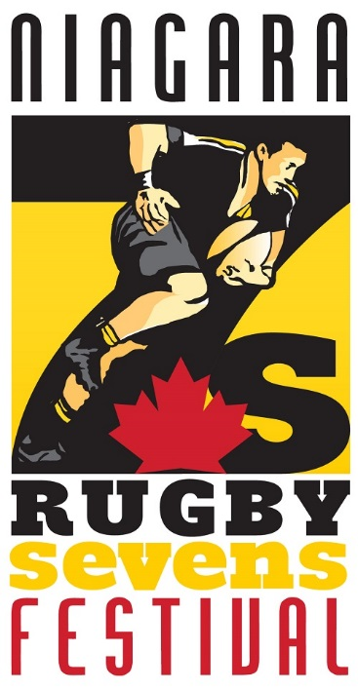
The Niagara Rugby 7s Festival offers teams from far and wide a memorable experience within the confines of Niagara’s bustling sport community. In what is becoming an increasingly popular sport, the Niagara Sport Commission, in partnership with the Niagara Wasps, is proud to showcase this annual display of athletic prowess and energetic atmosphere. The Niagara Rugby 7s Festival is a two-day November offering that brings together athletes from various divisions, various experience levels, and various regions, all looking to take part in this festival-like event. More than just the high-paced action on the pitch, this event looks to celebrate the sport of rugby sevens, highlight not only the impressive talent, but also the sense of camaraderie, sportsmanship, and overall excitement.
Across the province, across the country, and even across the border, the Niagara Rugby 7s Festival continues to strive to become a standout event for the sport and for the Region. Regardless of the experience, the talent, or the location, this Niagara-based event has a spot for your teams. Past divisions have included: Boys High School and Girls High School; Men’s Premier and Women’s Premier; Men’s Club and Women’s Club; and Men’s College/University and Women’s College/University, so whether you want to test your skill against some formidable competition, experience the thrill and excitement of a rugby sevens event, or simply see what this incredible event has to offer, the Niagara Rugby 7s Festival has it all.
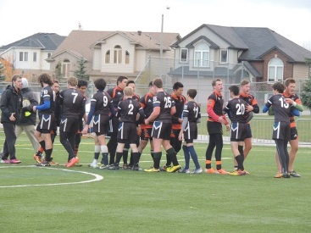
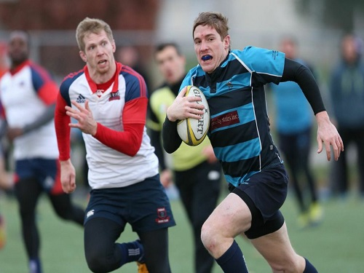
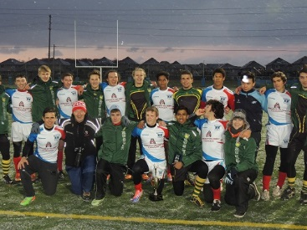
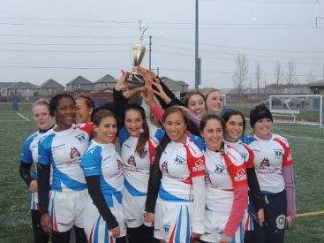

About Rugby Sevens
Rugby sevens, as the name suggests, involves teams made up of seven players, as opposed to the traditional 15, and is played across two seven-minute halves. Aside from these critical adjustments, much of the play is kept unchanged from the traditional running, as the athletes look to push the ball forward via crisp lateral or backward passing, determined forward runs, and hard-fought battles for possession. Overall, rugby sevens offers plenty of action, some intense speed and skill, and a number of impressive plays that excite fans like few other sports can.
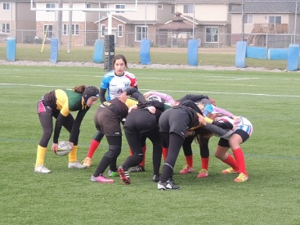
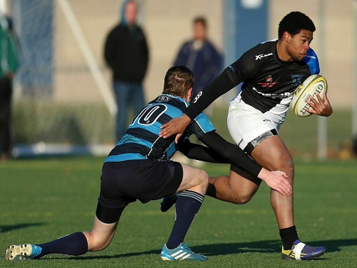

Past Winners
2016
Women’s College/University Division – Flemming def. Brock 12-10
Men’s College/University Division – Silverbacks def. Trent(1) 17-10
Women’s Club Division – Ladyboys def. Saxons 17-0
Men’s Club Division – Belleville def. Niagara Black 20-12 U18 Girls Division – WNY def. Mont Tremblant 12-5
U18 Boys Division – Niagara def. Mont Tremblant 22-17
2015
High School Boys Division – T.A. Blakelock
High School Girls Division – St. Mary’s Thunder U16 Boys Division – Norfolk Harvesters
Women’s Premier Division – Ormstown
2014
High School Boys Division – Upright Rugby def. NRU 15-14
High School Girls Division – Upright Rugby def. Beamsville 42-12
Men’s Club Division – Wasps & Tigers def. Mohawk College 21-19
Men’s Premier Division – Brock University Men’s Rugby def. Stoney Creek 19-10
2013
High School Boys Division – St. Mary’s Thunder def. Grimsby Eagles (Black) 20-0
High School Girls Division – St. Mary’s Thunder def. St. Michaels Mustangs 10-0
Men’ Division – Balmy Beach Men’s Rugby
Women’s Division – Stoney Creek Women’s Rugby
2012
High School Boys Division – St. Mary’s Thunder def. Stamford Hornets 36-0
High School Girls Division – St. Mary’s Thunder def. Stamford Hornets 26-7
Men’s Division – Niagara Wasps def. Cobourg Saxons 31-7
Women’s Division – University of Montreal Carabins def. Niagara Wasps 24-0
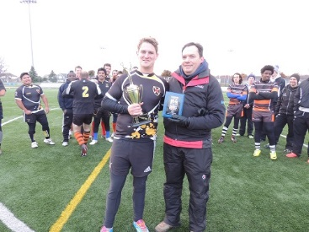
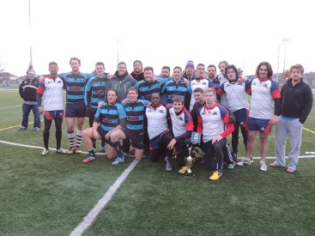
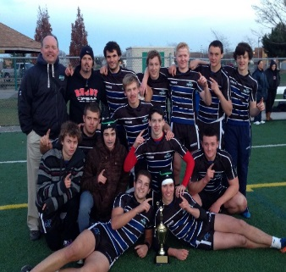
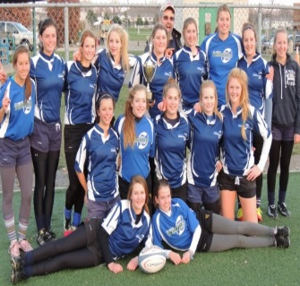
Contact
For more information on the Niagara Rugby 7s Festival, please see the contact information below:
Bram Cotton
Executive Director
Niagara Sport Commission
289-362-2215
bram.cotton@niagarasportcommission.com
Chris Hodgson
President
Niagara Wasps Rugby Club
905-353-7478
president@niagararugby.com

